Air Quality monitoring

Development -( phase-4)

# Introduction:

Air quality monitoring is the systematic process of measuring and assessing the composition of the air in a specific location to determine the presence of pollutants and their concentration. It plays a crucial role in environmental protection and public health.

The primary objectives of air quality monitoring include:

1. Pollutant Detection: Identifying and quantifying various pollutants in the atmosphere, such as particulate matter (PM), gases like carbon monoxide (CO), sulfur dioxide (SO2), nitrogen oxides (NOx), ozone (O3), and volatile organic compounds (VOCs).

2. Regulatory Compliance: Ensuring that air quality meets government-set standards and regulations to safeguard human health and the environment.

3. Public Health: Monitoring air quality is essential to protect public health. Poor air quality can lead to respiratory problems, cardiovascular diseases, and other health issues.

4. Environmental Protection: It helps in assessing the impact of human activities, such as industrial emissions and vehicular traffic, on the environment, including air quality, ecosystems, and climate change.

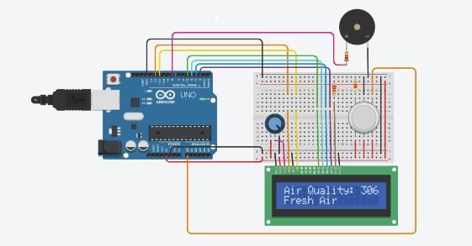

Air quality monitoring involves the use of various instruments and technologies, including air quality sensors, meteorological instruments, and data analysis systems. Data collected from monitoring stations is analyzed and used to make informed decisions on pollution control, policy development, and public advisories. Continuous monitoring and real-time data reporting are increasingly important in addressing air quality issues.

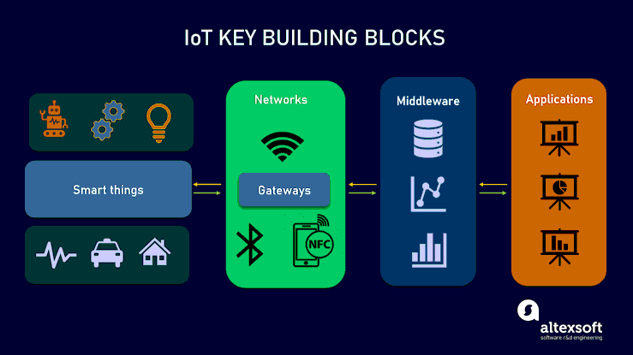

Step-by-Step Transformation of the Air Quality Monitoring Design:

1. Requirement Analysis:

- Understand and document the precise requirements of the system, such as

the metrics to be tracked (PM2.5, PM10, temperature, humidity, etc.), frequency

of data updates, and target audience (public, government, etc.).

2. Hardware Procurement:

- Acquire reliable IoT devices that can measure air quality metrics. Choose

sensors that are accurate, have longevity, and can operate in varied

environments.

3. Backend Development:

- Create a backend server using a technology like Node.js or Python

(Flask/Django). This server will:

- Communicate with the IoT devices to receive real-time data.

- Store this data in a database, such as PostgreSQL, MySQL, or a time-series

database like InfluxDB, optimized for time-stamped data.

- Offer an API for the frontend to fetch real-time and historical data.

4. Frontend Development:

- Refine the basic platform designed in the previous step. Make it responsive so

it can adapt to various devices like mobiles, tablets, and desktops.

- Use frameworks/libraries like React or Vue.js to make the dashboard dynamic

and real-time.

- Integrate data visualization tools or libraries like Chart.js or D3.js to display

data trends over time.

5. Testing:

- Test the IoT sensors in various conditions to ensure accurate data collection.

- Conduct unit tests on backend and frontend components.

- Perform integration tests to ensure seamless interaction between frontend,

backend, and IoT devices.

- Test the platform's performance under high loads to ensure scalability.

6. Deployment:

- Deploy the backend server on cloud platforms such as AWS, Azure, or Google

Cloud.

- Set up a Continuous Integration/Continuous Deployment (CI/CD) pipeline to

automate deployment processes.

- Use platforms like Netlify, Vercel, or traditional web hosts to deploy the

frontend.

7. Monitoring and Maintenance:

- Monitor the health of IoT devices. Set up alerts for device failures or

anomalies.

- Monitor the health of the backend server, ensuring uptime and performance.

- Periodically check for software updates, security patches, and other relevant

enhancements.

8. Feedback Loop:

- Encourage users to provide feedback on the platform's usability and features.

- Use this feedback to make iterative improvements, ensuring the solution

remains user-centric.

9. Expansion and Scalability:

- Based on usage trends and user feedback, plan for potential expansions. This

might include adding more IoT devices in new locations or integrating more

advanced analytics features.

- Ensure that the server and database can handle increased loads, which might

require optimizations or migrating to more robust systems.

10. Public Awareness and Education:

- Create educational content that explains air quality metrics, their significance,

and any health implications. This helps users interpret the data and understand its

importance.

- Collaborate with local governments or environmental agencies to increase

platform visibility and reach.

11. Continuous Innovation:

- Explore new technologies or methods that can enhance data accuracy or offer

new insights.

- Integrate AI and Machine Learning models to predict air quality trends or

detect anomalies.

- Look for partnership opportunities with environmental organizations, tech

companies, or academic institutions to further enhance and refine the platform.

By following these steps meticulously, the design can be transformed into a

comprehensive air quality monitoring solution, capable of delivering real-time

insights while being adaptable to future enhancements and innovations

Building a platform to display real-time air quality data involves several

components – the frontend (what users interact with), the backend (the server

logic and database operations), and the connection to IoT devices.

Here's a step-by-step guide:

1. Backend Development:

Technologies: Node.js (Express.js framework) and MongoDB as a database.

Steps:

a. Setup Express.js:

Install required packages:

bash

npm init

npm install express mongoose body-parser

b. Connect to MongoDB using Mongoose:

javascript

const mongoose = require('mongoose');

mongoose.connect('mongodb://localhost:27017/airQualityDB',

{useNewUrlParser: true, useUnifiedTopology: true});

c. API Endpoint to receive data from IoT devices:

javascript

app.post('/updateData', (req, res) => {

// Save the data to MongoDB

});

2. Frontend Development:

Technologies: HTML, CSS, JavaScript, and AJAX (to fetch real-time data).

Steps:

a. Create HTML Structure (`index.html`):

html

<!DOCTYPE html>

<html lang="en">

<head>

<meta charset="UTF-8">

<meta name="viewport" content="width=device-width, initial-scale=1.0">

<title>Air Quality Dashboard</title>

<link rel="stylesheet" href="styles.css">

</head>

<body>

<h1>Air Quality Data</h1>

<div id="data">

<!-- Data from the server will be populated here -->

</div>

<script src="script.js"></script>

</body>

</html>

b. Style with CSS (`styles.css`):

css

body {

font-family: Arial, sans-serif;

padding: 20px;

}

c. Fetch and Display Data (`script.js`):

javascript

function fetchData() {

fetch('/updateData')

.then(response => response.json())

.then(data => {

// Populate the data into the 'data' div

document.getElementById("data").innerHTML = `

PM2.5: ${data.pm25} <br>

PM10: ${data.pm10} <br>

Temperature: ${data.temperature}°C <br>

Humidity: ${data.humidity}%

`;

});

}

// Fetch data every 10 seconds

setInterval(fetchData, 10000);

3. Connection to IoT Devices:

Assuming the IoT devices can send HTTP POST requests, they'll send data to the

`/updateData` endpoint. The backend (Express.js server) will process this data,

save it to MongoDB, and then the frontend will fetch and display this data at

regular intervals.

4. Deployment:

Backend:

- Use platforms like Heroku, DigitalOcean, or AWS to deploy the Node.js server.

Frontend:

- Host static files using services like Netlify, Vercel, or traditional web hosts.

5. Secure Data Transfer:

- Use HTTPS to ensure the data being sent from IoT devices to the server is

encrypted.

- Authenticate IoT devices to prevent unauthorized data from entering the

system.

Remember, this is a basic implementation. In a real-world scenario, you'll need to

consider scalability, handle potential errors, secure the data, and regularly update

the platform based on user feedback and technological advancements.

conclusion:

Air quality monitoring is a critical endeavor with far-reaching implications for public health, environmental protection, and regulatory compliance. This comprehensive process involves the systematic measurement and analysis of air pollutants to ensure the well-being of communities and ecosystems. From the selection of monitoring sites to the development of sophisticated data platforms, each step is integral to the success of the project.

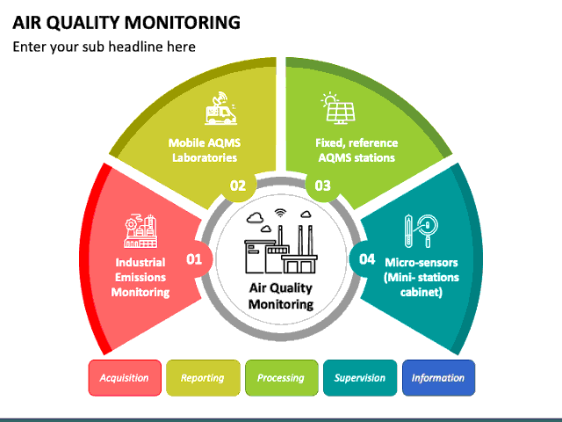

Collaboration with regulatory bodies, research institutions, and the wider community is key to addressing air quality challenges comprehensively and effectively

By building a platform that can seamlessly receive and display real-time air quality data from distributed IoT devices, we empower individuals and communities with timely insights into their surroundings.

As we move forward in this digital age, leveraging these technologies will be essential in fostering sustainable urban environments and safeguarding public health.